

**HOOTSUITE GUIDE**

**ESSENTIAL HOOTSUITE ADVICE FOR SEGA’S DIGITAL MARKETING TEAM**

**CONTENTS**

**Introduction – Page 3**

**Setting up HootSuite – Page 4-6**

**How to Post & Schedule – Page 7-9**

**How to Create a Report – Page 10-11**

**Collaboration – Page 12**

**INTRODUCTION**

This guide is for the digital marketing team at Sega to learn how to use HootSuite efficiently and consistently throughout

HootSuite is a Customer Relationship Management tool that can be used to improve the marketing strategies of companies on Social Media. It can improve the usage of Social Media in terms of consistency, interaction and overall management, as well as helping Sega to manage their statistics for these Social Media sites all in one place.

Some of the features of HootSuite include:

* Managing multiple streams in one place
* Scheduling of posts
* Real time analytics
* Customized reports

**01 SETTING UP**

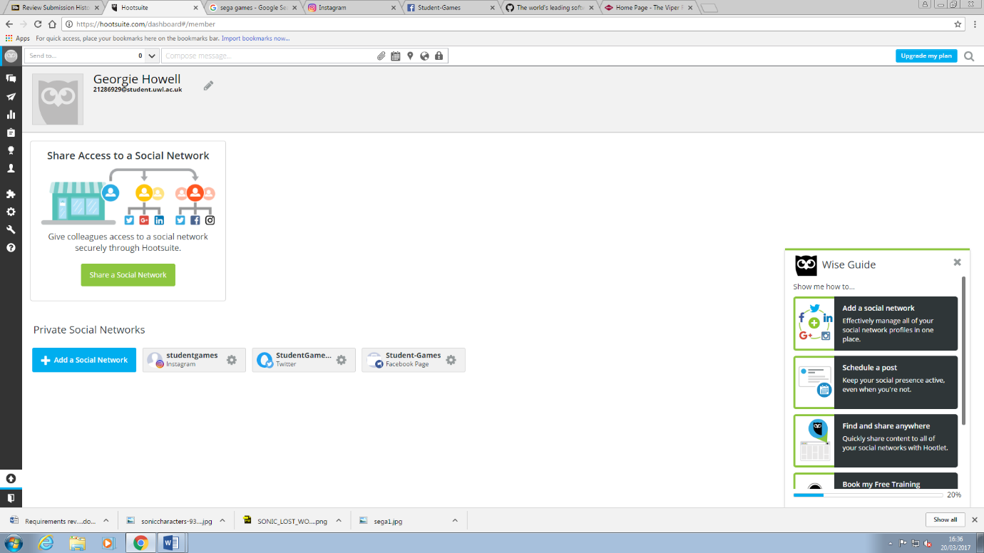

In order to add a new Social Network, you must click on the owl icon. This leads you to a page to manage your Social Network account (shown above).

To add a new one, click ‘Add a Social Network’ and sign in.

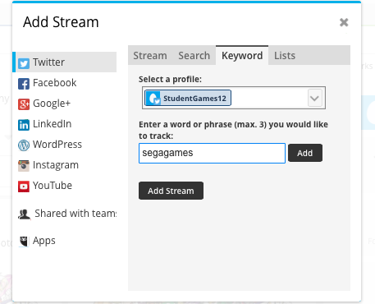

SCENARIO: If Sega want to keep track of a key term used on Twitter, for example ‘Sonic’, they can add a stream for each time the word Sonic is used in a tweet and this will let them see every post with this word in it

DEFINITION: A stream is a continuous flow of data or materials transmitted over the internet. For example, your Twitter and Facebook home pages are continuous flows of posts.

Streams are just like your Twitter home feed. You can create streams to monitor your timeline, hashtags, brand mentions, keywords and more.

You can organise streams under tabs, much like tabs on filing folders.

Each Hootsuite account can add up to 20 tabs, and each tab holds 10 streams.

Choose a Social Media account and a stream to add.

The example image is showing how to add a key word stream; simply type the word you want to track as a hashtag.

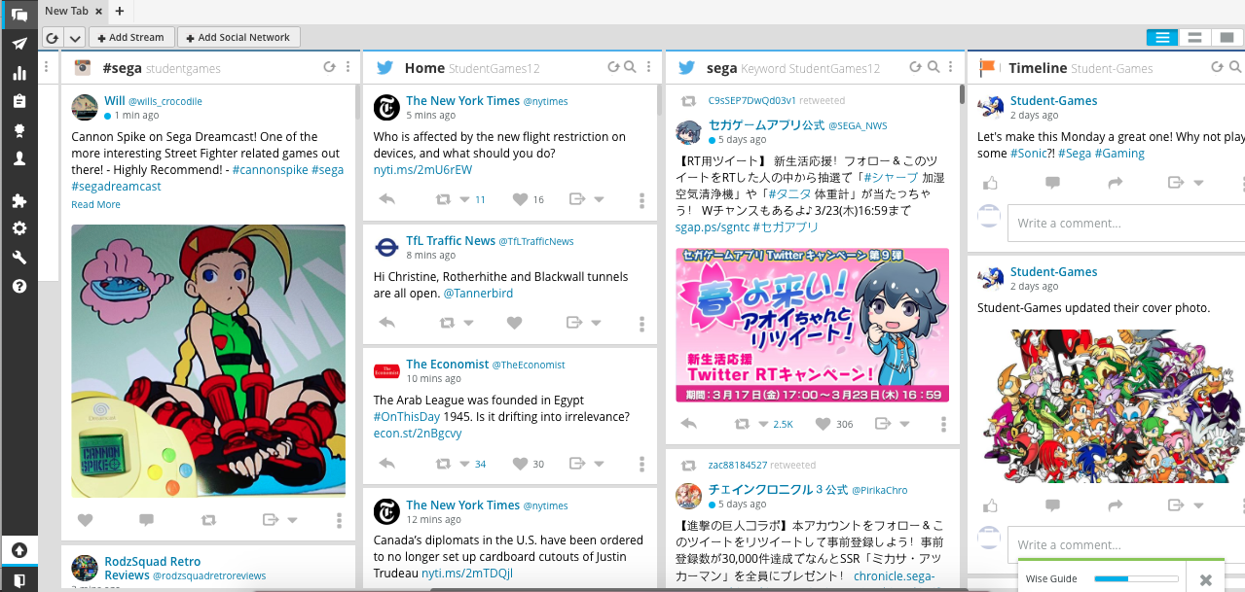

Once you have added all the social media accounts and chosen what streams you want to view, this is what your Hootsuite dashboard will look like.

**02 HOW TO POST & SCHEDULE**

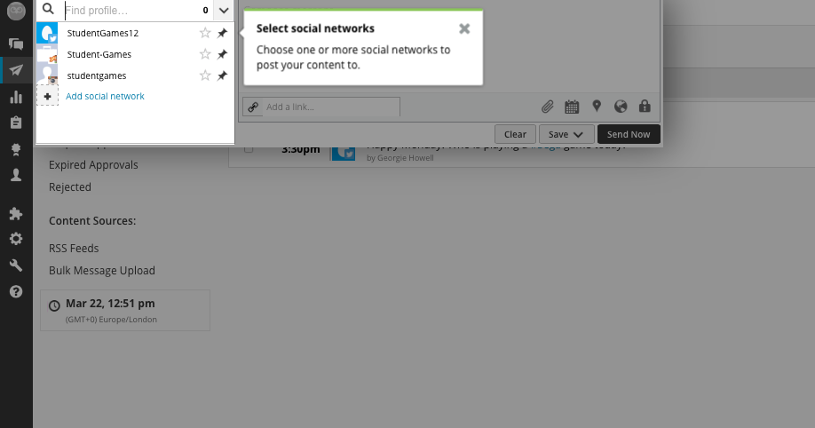

In order to start publishing the post first click on the ‘arrow’ symbol on the side bar.

From all the streams you have added you then chose the account that you want to tweet from.

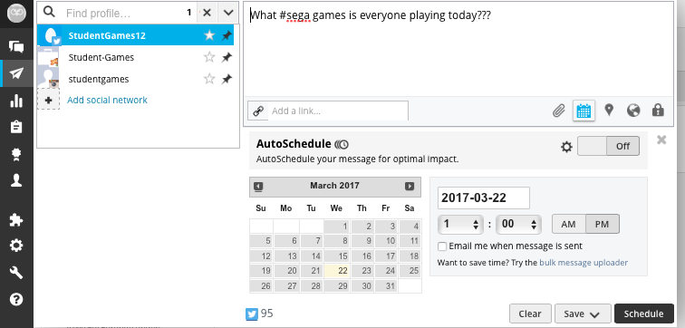

You then type your post in the box where there are features to add media, add links and add location

Once the post is finish you can either click ‘send now’ or click on the calendar icon in order to schedule the post for the desired time. You simply add the date and the time you want it to be published. This can be done manually each time or you can send it for ‘auto-schedule’.

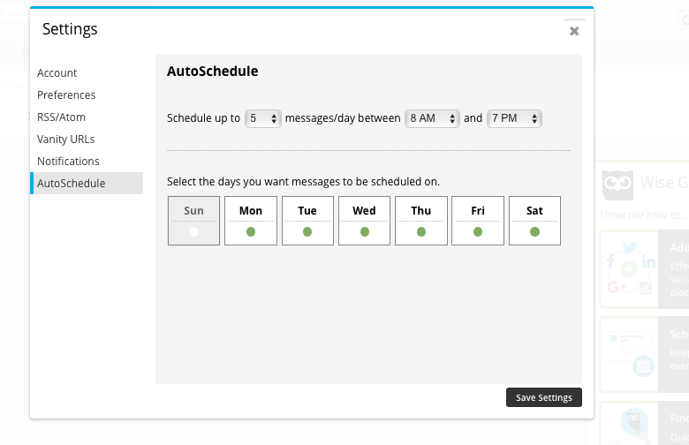

This is auto-scheduling where you can make up to 5 posts (more on the professional account) to go out on the chosen days within the time slot.

You can then view all your scheduled tweets in a calendar and make any amendments if necessary.

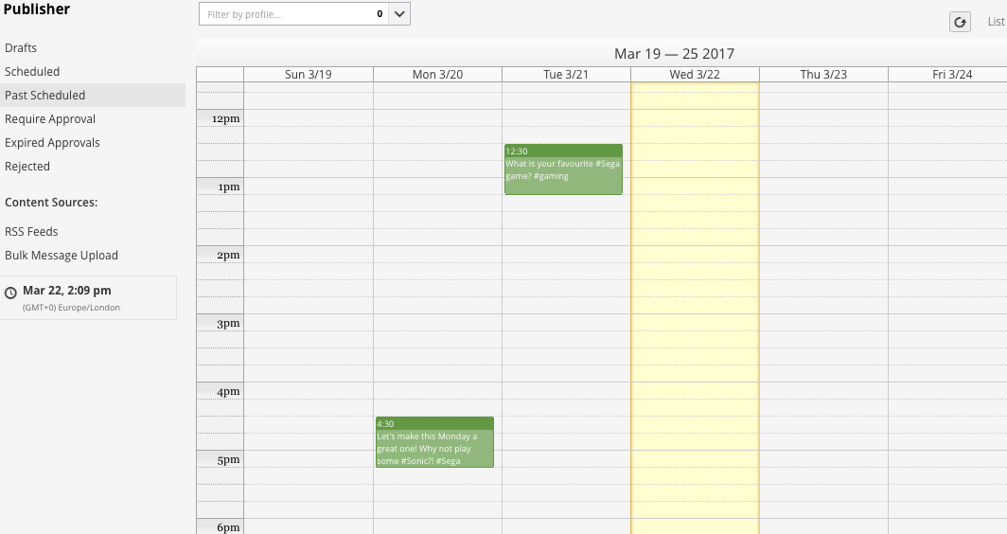

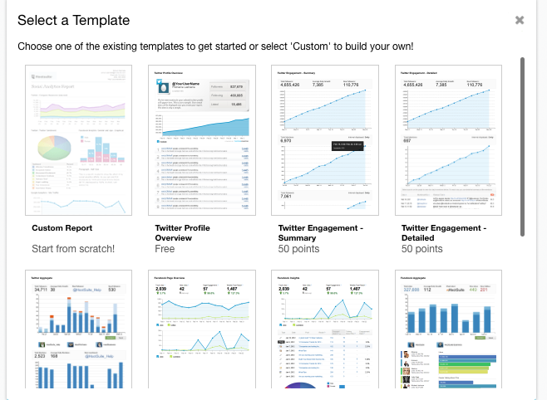

**03 HOW TO CREATE REPORTS**

Clicking on the graph icon on the left side bar will take you to the analytics section.

You can click on ‘create reports’ and get different reports on the chosen social media profile.

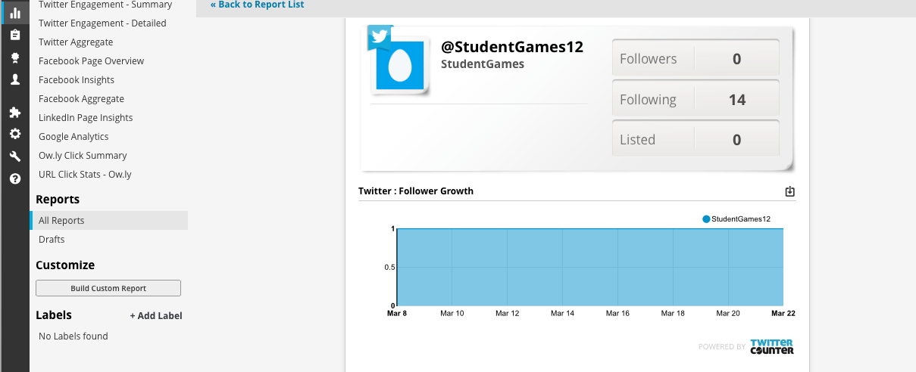

Above is a basic example of a twitter account report, showing overall profile view and follower growth. There are a lot of other features you can add to a report to have more in depth analysis.

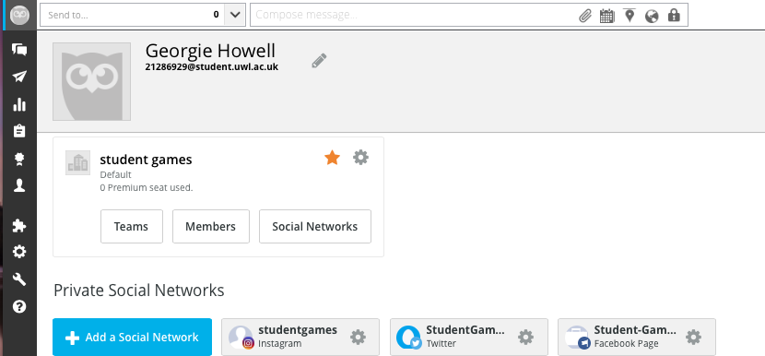**04 COLLABORATION**

Assignments are a team collaboration feature available to Hootsuite Pro, Team, Business and Enterprise users. Social media profiles can be assigned for action amongst teams and team members, allowing comprehensive and efficient replying across your organization’s social networks.